|  |
| --- |
| **VISVESVARAYA TECHNOLOGICAL UNIVERSITY**  **“JnanaSangama”, Belgaum -590014, Karnataka.**    **LAB RECORD**  **Bio Inspired Systems (23CS5BSBIS)**  ***Submitted by***  **Chethan T M(1BM23CS076)**  ***in partial fulfillment for the award of the degree of***  **BACHELOR OF ENGINEERING**  ***in***  **COMPUTER SCIENCE AND ENGINEERING**    **B.M.S. COLLEGE OF ENGINEERING**  **(Autonomous Institution under VTU)**  **BENGALURU-560019**  **Aug-2025 to Dec-2025** |

**B.M.S. College of Engineering,**

**Bull Temple Road, Bangalore 560019**

(Affiliated To Visvesvaraya Technological University, Belgaum)

**Department of Computer Science and Engineering**



**CERTIFICATE**

This is to certify that the Lab work entitled “Bio Inspired Systems (23CS5BSBIS)” carried out by **Chethan T M (1BM23CS076),** who is bonafide student of **B.M.S. College of Engineering.** It is in partial fulfillment for the award of **Bachelor of Engineering in Computer Science and Engineering** of the Visvesvaraya Technological University, Belgaum. The Lab report has been approved as it satisfies the academic requirements of the above mentioned subject and the work prescribed for the said degree.

|  |  |
| --- | --- |
| Raghavendra C K  Assistant Professor  Department of CSE, BMSCE | Dr. Kavitha Sooda  Professor & HOD  Department of CSE, BMSCE |

**Index**

|  |  |  |  |
| --- | --- | --- | --- |
| **Sl.**  **No.** | **Date** | **Experiment Title** | **Page No.** |
| 1 | 18/08/2025 | Genetic Algorithm for Optimization Problems | 1-7 |
| 2 | 25/08/2025 | Optimization via Gene Expression Algorithms | 8-13 |
| 3 | 01/09/2025 | Particle Swarm Optimization for Function Optimization | 14-18 |
| 4 | 08/09/2025 | Ant Colony Optimization for the TSP | 19-25 |
| 5 | 15/09/2-05 | Cuckoo Search (CS): | 26-30 |
| 6 | 29/09/2025 | Grey Wolf Optimizer (GWO): | 31-35 |
| 7 | 13/10/2025 | Parallel Cellular Algorithms and Programs: | 36-40 |

GitHub Link:

https://github.com/Chethushub/BIS-Lab

**Program 1**

**Genetic Algorithm for Optimization Problems**:

Genetic Algorithms (GA) are inspired by the process of natural selection and genetics, where the fittest individuals are selected for reproduction to produce the next generation. GAs are widely used for solving optimization and search problems. Implement a Genetic Algorithm using Python to solve a basic optimization problem, such as finding the maximum value of a mathematical function. Implementation Steps:

1. Define the Problem: Create a mathematical function to optimize.

2. Initialize Parameters: Set the population size, mutation rate, crossover rate, and number of generations.

3. Create Initial Population: Generate an initial population of potential solutions.

4. Evaluate Fitness: Evaluate the fitness of each individual in the population.

5. Selection: Select individuals based on their fitness to reproduce.

6. Crossover: Perform crossover between selected individuals to produce offspring.

7. Mutation: Apply mutation to the offspring to maintain genetic diversity.

8. Iteration: Repeat the evaluation, selection, crossover, and mutation processes for a fixed number of generations or until convergence criteria are met.

9. Output the Best Solution: Track and output the best solution found during the generations.

Algorithm:

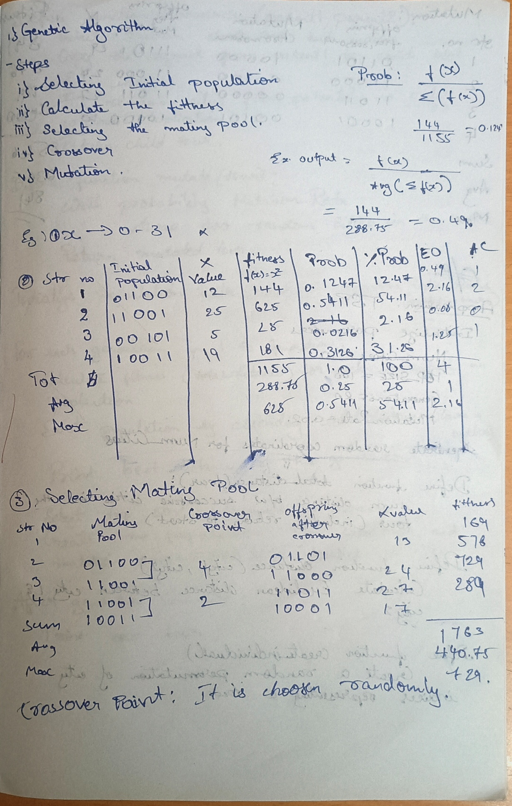

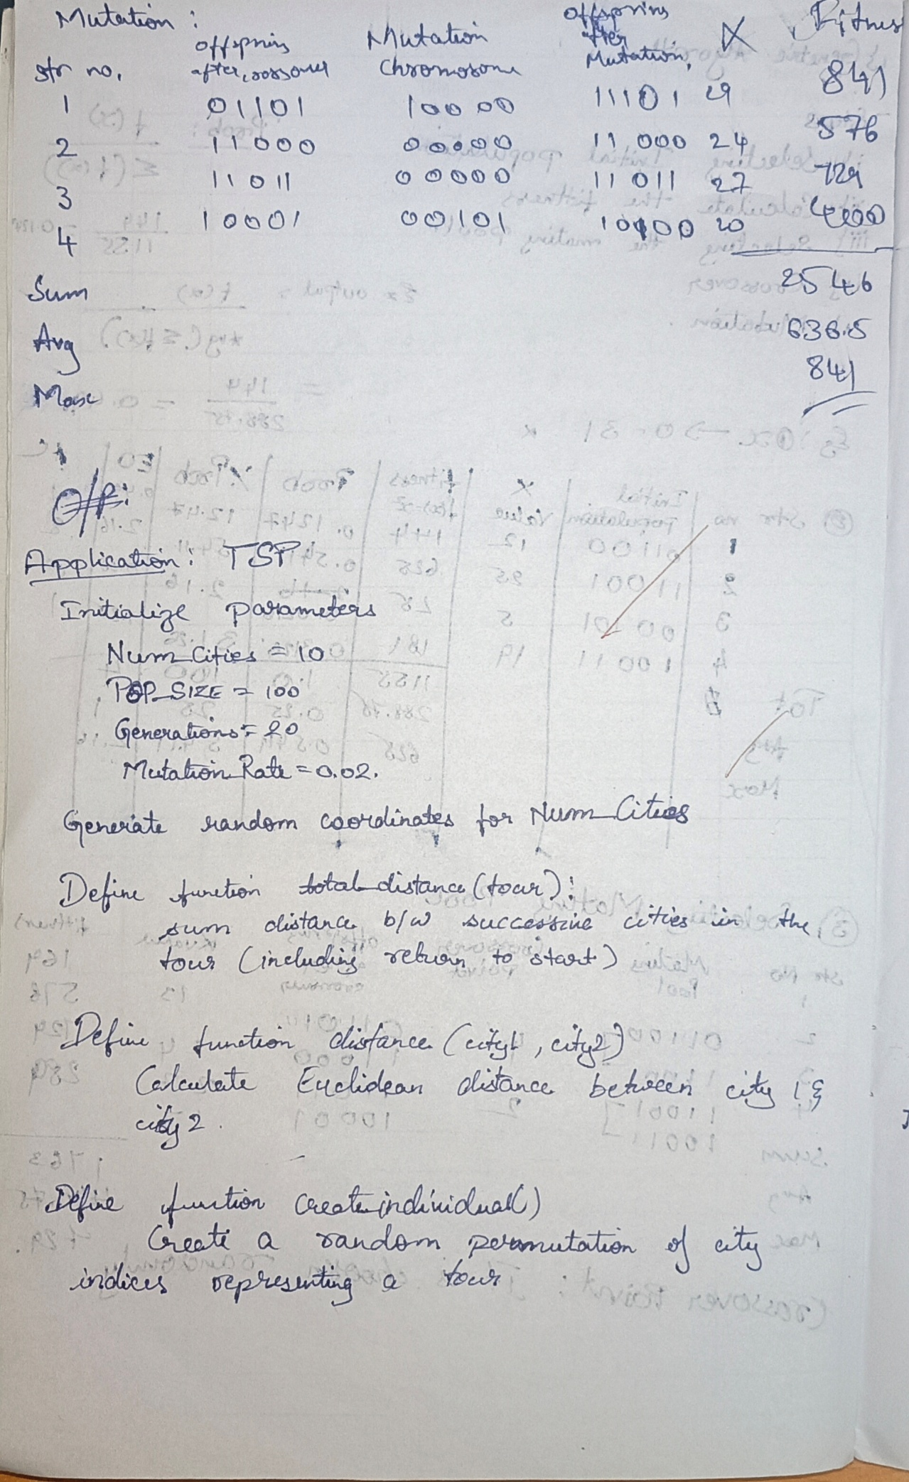

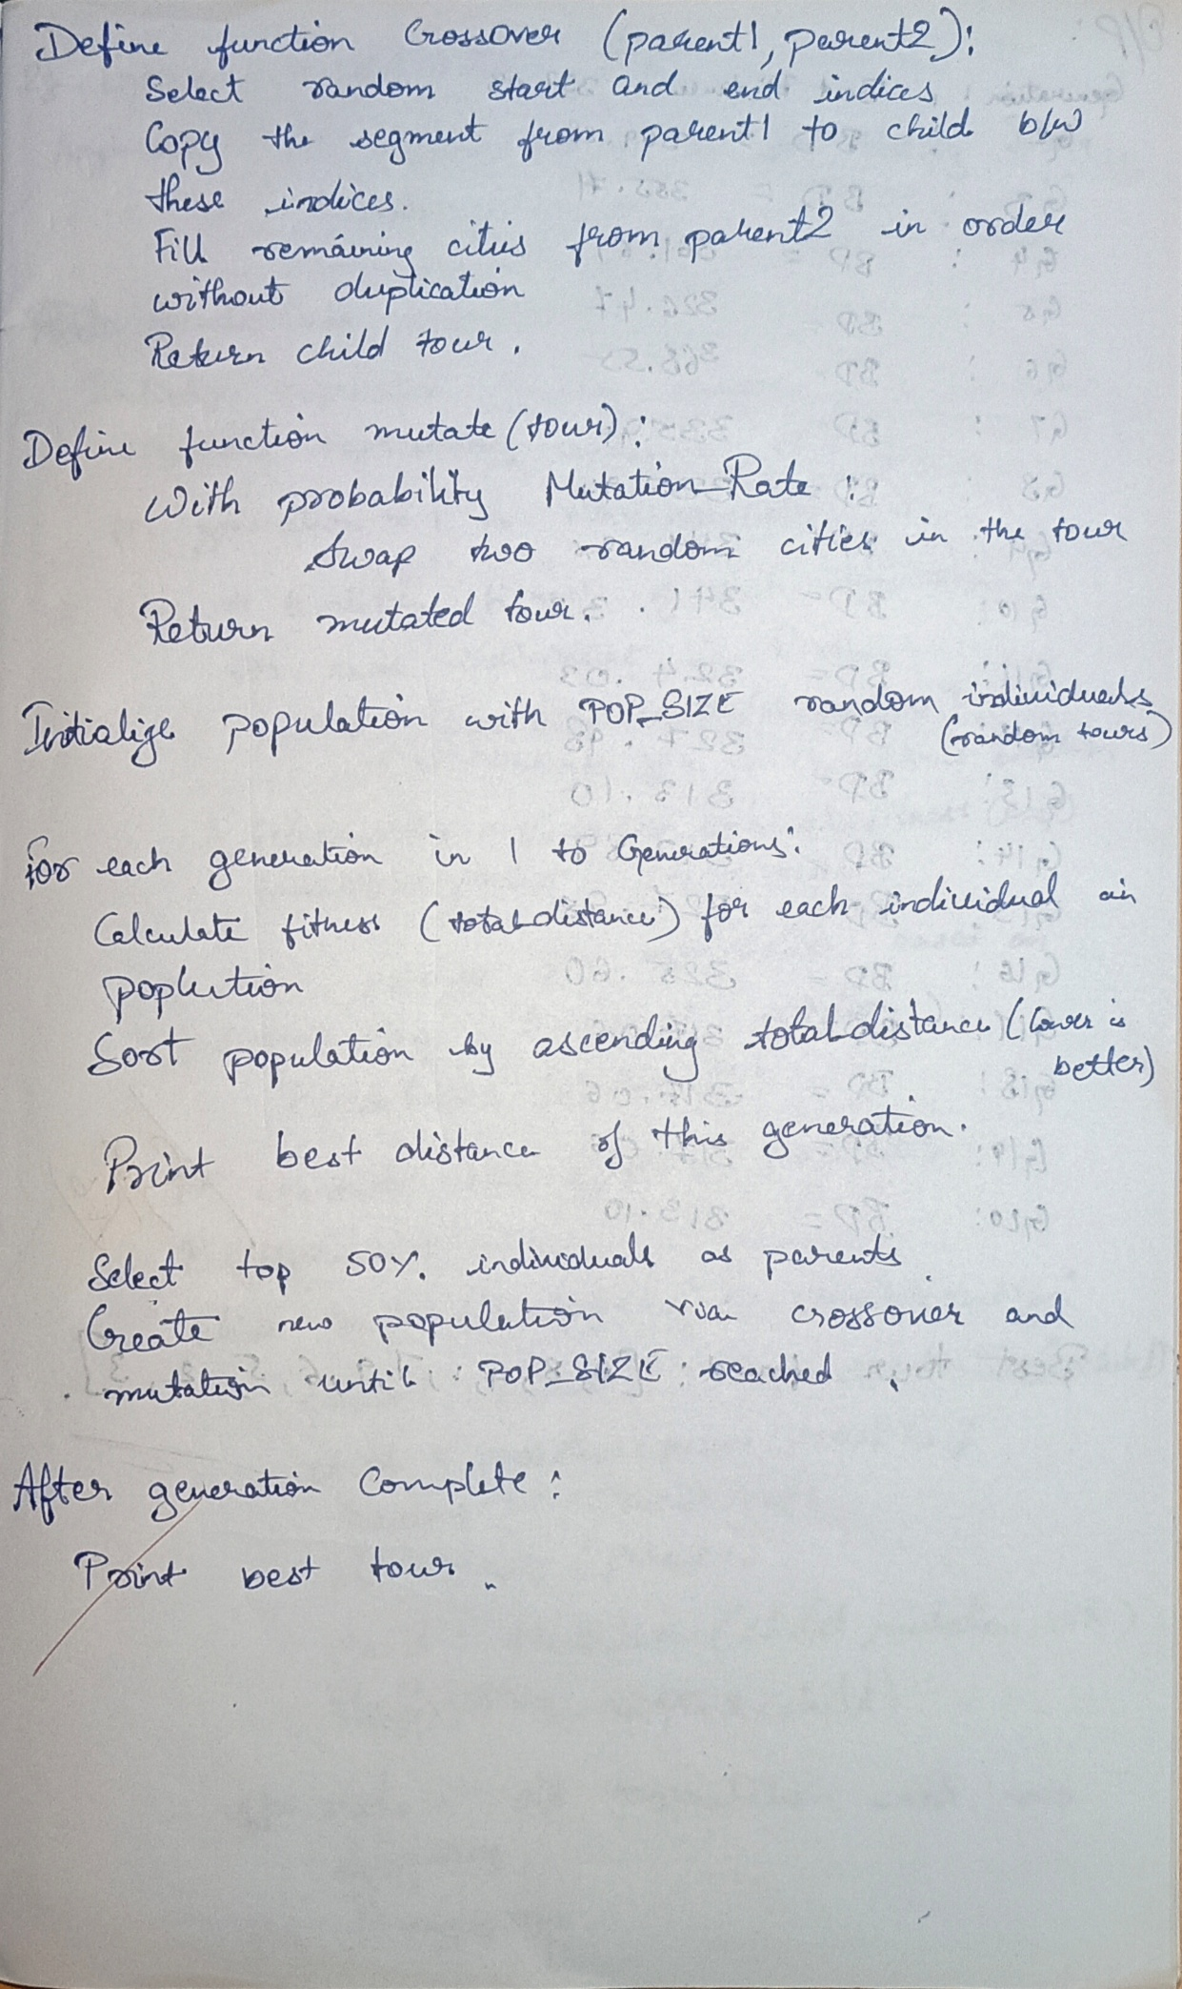

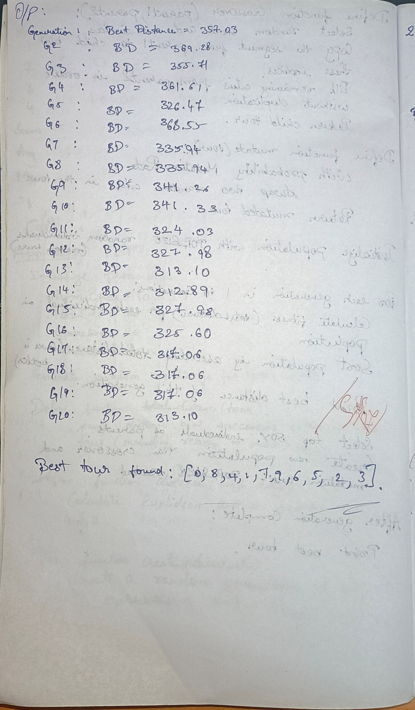

Code:

import random

import math

# -----------------------------

# CONFIG

NUM_CITIES = 10

POP_SIZE = 100

GENERATIONS = 20

MUTATION_RATE = 0.02

# -----------------------------

# Generate random cities

cities = [(random.uniform(0, 100), random.uniform(0, 100)) for _ in range(NUM_CITIES)]

# -----------------------------

# Distance between two cities

def distance(city1, city2):

return math.hypot(city1[0] - city2[0], city1[1] - city2[1])

# Total path length (fitness is inverse)

def total_distance(tour):

return sum(distance(cities[tour[i]], cities[tour[(i+1) % NUM_CITIES]]) for i in range(NUM_CITIES))

# -----------------------------

# Create random individual (a tour)

def create_individual():

tour = list(range(NUM_CITIES))

random.shuffle(tour)

return tour

# Crossover: Order Crossover (OX)

def crossover(parent1, parent2):

start, end = sorted(random.sample(range(NUM_CITIES), 2))

child = [None] * NUM_CITIES

# Copy slice from first parent

child[start:end+1] = parent1[start:end+1]

# Fill in the rest from second parent

ptr = 0

for city in parent2:

if city not in child:

while child[ptr] is not None:

ptr += 1

child[ptr] = city

return child

# Mutation: Swap two cities

def mutate(tour):

if random.random() < MUTATION_RATE:

i, j = random.sample(range(NUM_CITIES), 2)

tour[i], tour[j] = tour[j], tour[i]

return tour

# -----------------------------

# Initial population

population = [create_individual() for _ in range(POP_SIZE)]

# -----------------------------

# Main GA loop

for gen in range(GENERATIONS):

# Evaluate fitness

scored = [(ind, total_distance(ind)) for ind in population]

scored.sort(key=lambda x: x[1]) # lower distance is better

best = scored[0]

print(f"Generation {gen+1}: Best distance = {best[1]:.2f}")

# Selection: keep top 50%

selected = [ind for ind, _ in scored[:POP_SIZE // 2]]

# Reproduce

children = []

while len(children) < POP_SIZE:

p1, p2 = random.sample(selected, 2)

child = crossover(p1, p2)

child = mutate(child)

children.append(child)

population = children

# Final best route

best_tour = scored[0][0]

print("\nBest tour found:", best_tour)

**Program 2**

**Optimization via Gene Expression Algorithms:**

Gene Expression Algorithms (GEA) are inspired by the biological process of gene expression in living organisms. This process involves the translation of genetic information encoded in DNA into functional proteins. In GEA, solutions to optimization problems are encoded in a manner similar to genetic sequences. The algorithm evolves these solutions through selection, crossover, mutation, and gene expression to find optimal or near-optimal solutions. GEA is effective for solving complex optimization problems in various domains, including engineering, data analysis, and machine learning. Implementation Steps:

1. Define the Problem: Create a mathematical function to optimize.

2. Initialize Parameters: Set the population size, number of genes, mutation rate, crossover rate, and number of generations.

3. Initialize Population: Generate an initial population of random genetic sequences.

4. Evaluate Fitness: Evaluate the fitness of each genetic sequence based on the optimization function. 5. Selection: Select genetic sequences based on their fitness for reproduction.

6. Crossover: Perform crossover between selected sequences to produce offspring.

7. Mutation: Apply mutation to the offspring to introduce variability.

8. Gene Expression: Translate genetic sequences into functional solutions.

9. Iterate: Repeat the selection, crossover, mutation, and gene expression processes for a fixed number of generations or until convergence criteria are met.

10. Output the Best Solution: Track and output the best solution found during the iterations.

Algorithm:

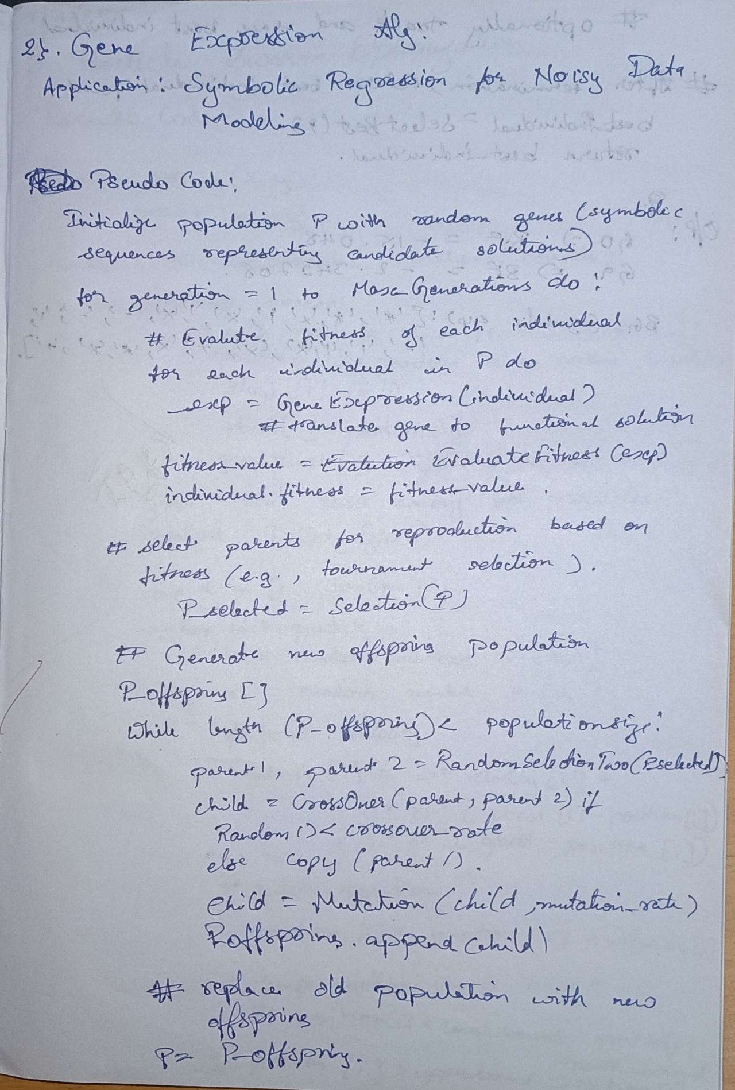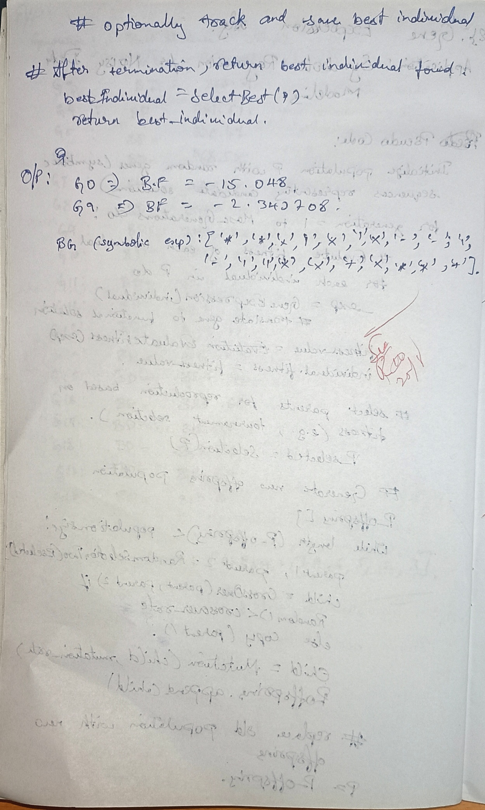

Code:

import numpy as np

import random

import operator

# Generate noisy data from a nonlinear function

def target_function(x):

return 2 * x**3 - x + 1

def generate_data(n_points=30):

xs = np.linspace(-2, 2, n_points)

ys = np.array([target_function(x) for x in xs]) + np.random.normal(0, 1, n_points)

return xs, ys

X_data, y_data = generate_data()

# Parameters

POP_SIZE = 50

GENE_LENGTH = 20

NUM_GENERATIONS = 10

MUTATION_RATE = 0.1

CROSSOVER_RATE = 0.7

# Function and terminal sets

FUNCTIONS = [('+', operator.add), ('-', operator.sub), ('*', operator.mul)]

TERMINALS = ['x', '1']

func_dict = {f[0]: f[1] for f in FUNCTIONS}

# Convert gene (list of symbols) into executable function

def express_gene(gene):

stack = []

for symbol in gene:

if symbol in func_dict:

try:

b = stack.pop()

a = stack.pop()

func = func_dict[symbol]

stack.append(lambda x, a=a, b=b, func=func: func(a(x), b(x)))

except IndexError:

stack.append(lambda x: 1)

elif symbol == 'x':

stack.append(lambda x: x)

elif symbol == '1':

stack.append(lambda x: 1)

else:

stack.append(lambda x: 1)

return stack[-1] if stack else lambda x: 1

# Fitness: negative MSE

def fitness(gene):

func = express_gene(gene)

try:

ys_pred = np.array([func(x) for x in X_data])

mse = np.mean((ys_pred - y_data) ** 2)

if np.isnan(mse) or np.isinf(mse):

return -float('inf')

return -mse

except Exception:

return -float('inf')

# Tournament selection

def selection(pop, k=3):

selected = random.sample(pop, k)

return max(selected, key=fitness)

# Crossover

def crossover(parent1, parent2):

if len(parent1) != len(parent2):

return parent1[:]

point = random.randint(1, len(parent1) - 2)

return parent1[:point] + parent2[point:]

# Mutation

def mutate(gene, mutation_rate=MUTATION_RATE):

gene = gene[:]

symbols = [f[0] for f in FUNCTIONS] + TERMINALS

for i in range(len(gene)):

if random.random() < mutation_rate:

gene[i] = random.choice(symbols)

return gene

# Initialize population

population = [[random.choice([f[0] for f in FUNCTIONS] + TERMINALS) for _ in range(GENE_LENGTH)] for _ in range(POP_SIZE)]

best_gene = None

best_fit = -float('inf')

# Main loop

for gen in range(NUM_GENERATIONS):

new_population = []

for _ in range(POP_SIZE):

parent1 = selection(population)

parent2 = selection(population)

child = crossover(parent1, parent2) if random.random() < CROSSOVER_RATE else parent1[:]

child = mutate(child)

new_population.append(child)

population = new_population

generation_best = max(population, key=fitness)

generation_best_fit = fitness(generation_best)

if generation_best_fit > best_fit:

best_fit = generation_best_fit

best_gene = generation_best

if gen % 10 == 0 or gen == NUM_GENERATIONS - 1:

print(f"Generation {gen}: Best fitness = {best_fit:.6f}")

# Output best gene and prediction results

print("Best gene (symbolic expression):", best_gene)

best_func = express_gene(best_gene)

print("Sample predictions vs actual values:")

for x, y_true in zip(X_data[:10], y_data[:10]):

try:

y_pred = best_func(x)

print(f"x={x:.3f}, Predicted={y_pred:.3f}, Actual={y_true:.3f}")

except Exception:

print(f"x={x:.3f}, Predicted=Error, Actual={y_true:.3f}")

**Program 3**

**Particle Swarm Optimization for Function Optimization:**

Particle Swarm Optimization (PSO) is inspired by the social behavior of birds flocking or fish schooling. PSO is used to find optimal solutions by iteratively improving a candidate solution with regard to a given measure of quality. Implement the PSO algorithm using Python to optimize a mathematical function. Implementation Steps:

1. Define the Problem: Create a mathematical function to optimize.

2. Initialize Parameters: Set the number of particles, inertia weight, cognitive and social coefficients. 3. Initialize Particles: Generate an initial population of particles with random positions and velocities. 4. Evaluate Fitness: Evaluate the fitness of each particle based on the optimization function.

5. Update Velocities and Positions: Update the velocity and position of each particle based on its own best position and the global best position.

6. Iterate: Repeat the evaluation, updating, and position adjustment for a fixed number of iterations or until convergence criteria are met.

7. Output the Best Solution: Track and output the best solution found during the iterations.

Algorithm:

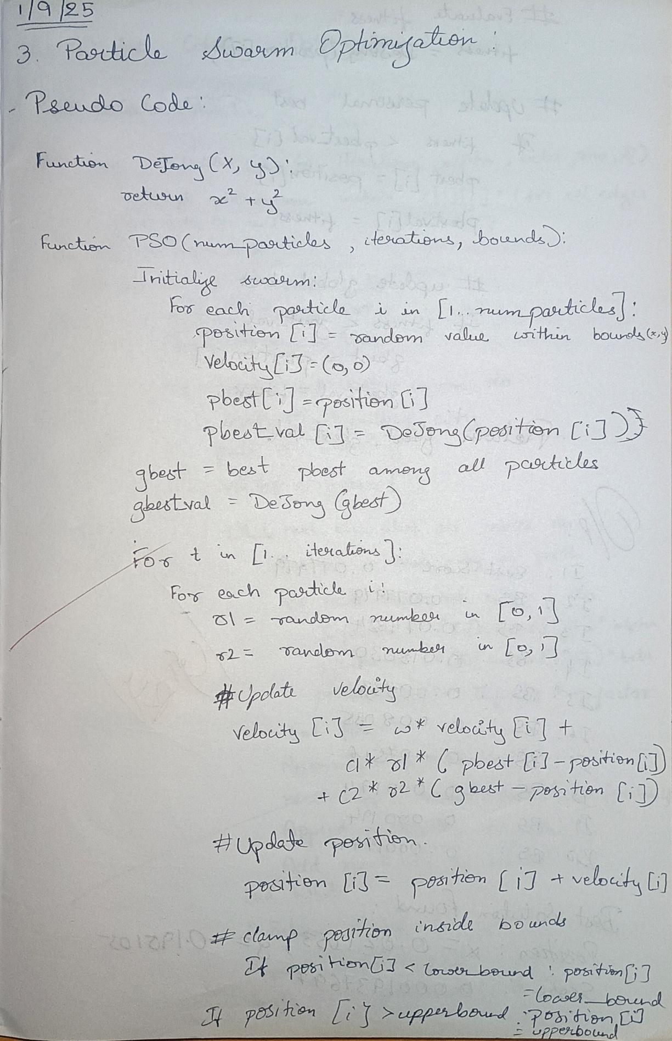

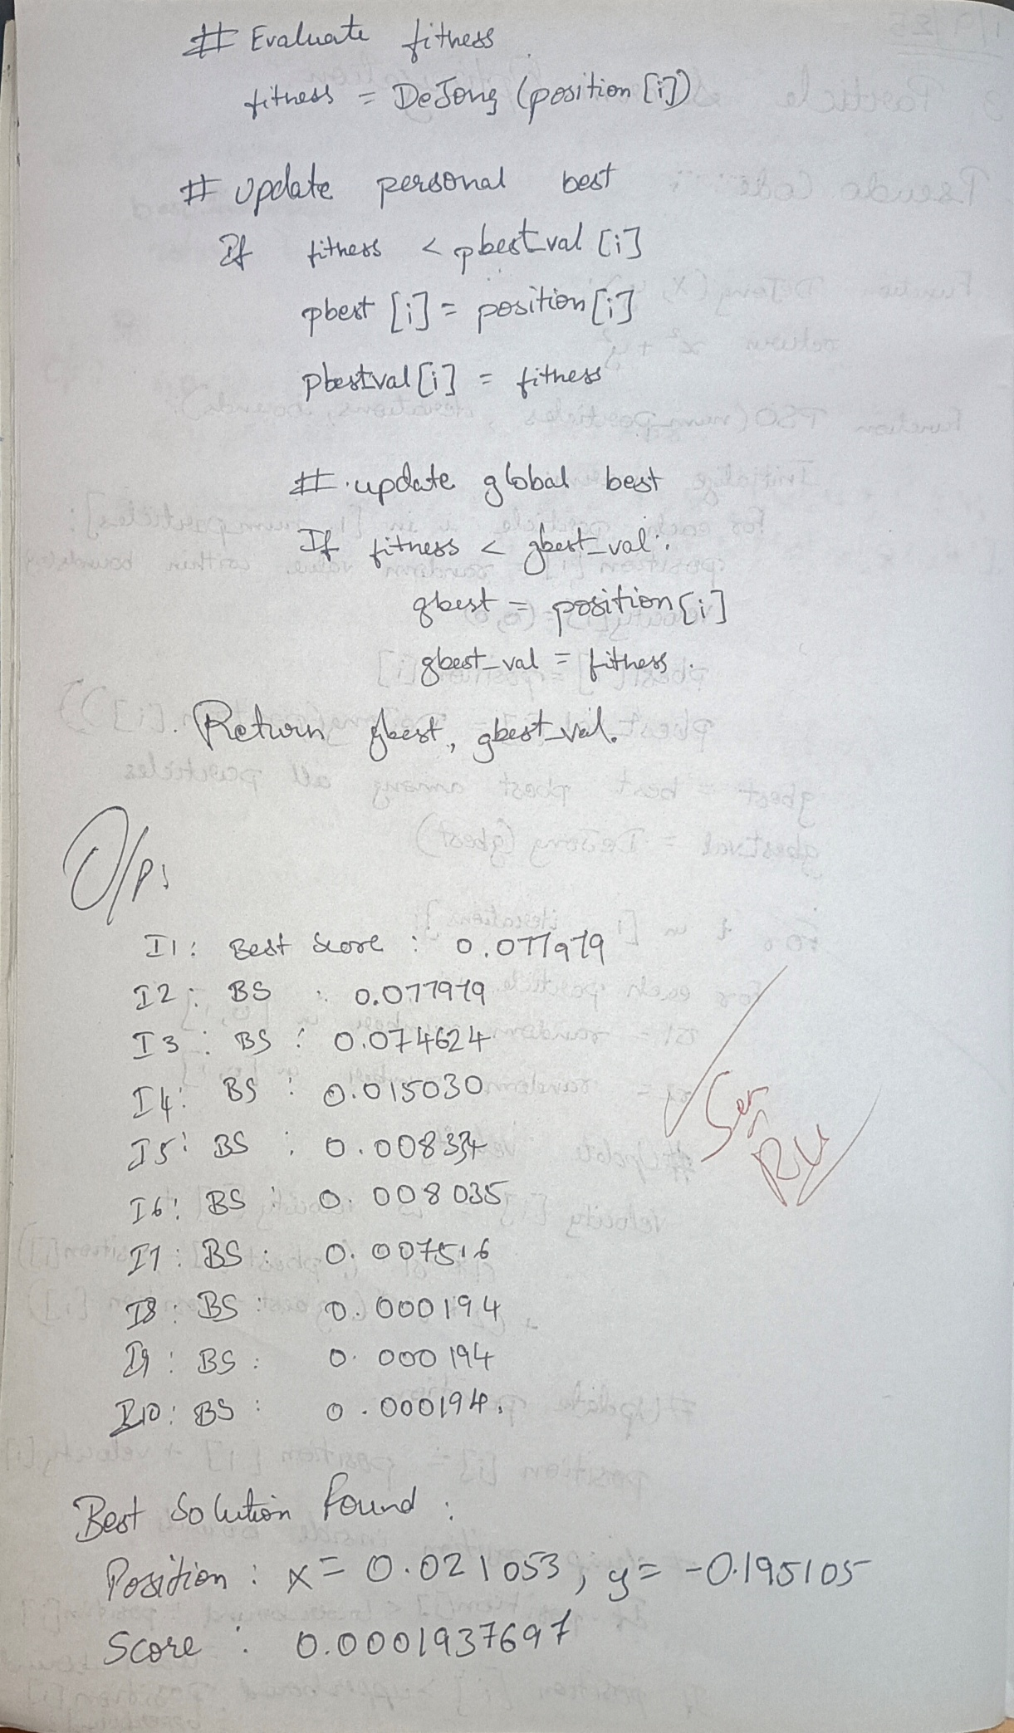

Code:

import numpy as np

def de_jong(position):

x, y = position

return x**2 + y**2

num_particles = 30

dimensions = 2

iterations = 10

w = 0.5

c1 = 1.5

c2 = 1.5

bounds = (-5.12, 5.12)

positions = np.random.uniform(bounds[0], bounds[1], (num_particles, dimensions))

velocities = np.random.uniform(-1, 1, (num_particles, dimensions))

pbest_positions = np.copy(positions)

pbest_scores = np.array([de_jong(p) for p in positions])

gbest_index = np.argmin(pbest_scores)

gbest_position = pbest_positions[gbest_index]

gbest_score = pbest_scores[gbest_index]

for t in range(iterations):

for i in range(num_particles):

r1 = np.random.rand(dimensions)

r2 = np.random.rand(dimensions)

velocities[i] = (w * velocities[i] +

c1 * r1 * (pbest_positions[i] - positions[i]) +

c2 * r2 * (gbest_position - positions[i]))

positions[i] += velocities[i]

positions[i] = np.clip(positions[i], bounds[0], bounds[1])

fitness = de_jong(positions[i])

if fitness < pbest_scores[i]:

pbest_positions[i] = positions[i]

pbest_scores[i] = fitness

if fitness < gbest_score:

gbest_position = positions[i]

gbest_score = fitness

print(f"Iteration {t+1:3d} | Best Score: {gbest_score:.6f}")

print("\nBest Solution Found:")

print(f"Position: x = {gbest_position[0]:.6f}, y = {gbest_position[1]:.6f}")

print(f"Score: {gbest_score:.10f}")

**Program 4**

**Ant Colony Optimization for the Traveling Salesman Problem:**

The foraging behavior of ants has inspired the development of optimization algorithms that can solve complex problems such as the Traveling Salesman Problem (TSP). Ant Colony Optimization (ACO) simulates the way ants find the shortest path between food sources and their nest. Implement the ACO algorithm using Python to solve the TSP, where the objective is to find the shortest possible route that visits a list of cities and returns to the origin city. Implementation Steps:

1. Define the Problem: Create a set of cities with their coordinates.

2. Initialize Parameters: Set the number of ants, the importance of pheromone (alpha), the importance of heuristic information (beta), the evaporation rate (rho), and the initial pheromone value.

3. Construct Solutions: Each ant constructs a solution by probabilistically choosing the next city based on pheromone trails and heuristic information.

4. Update Pheromones: After all ants have constructed their solutions, update the pheromone trails based on the quality of the solutions found.

5. Iterate: Repeat the construction and updating process for a fixed number of iterations or until convergence criteria are met.

6. Output the Best Solution: Keep track of and output the best solution found during the iterations.

Algorithm:

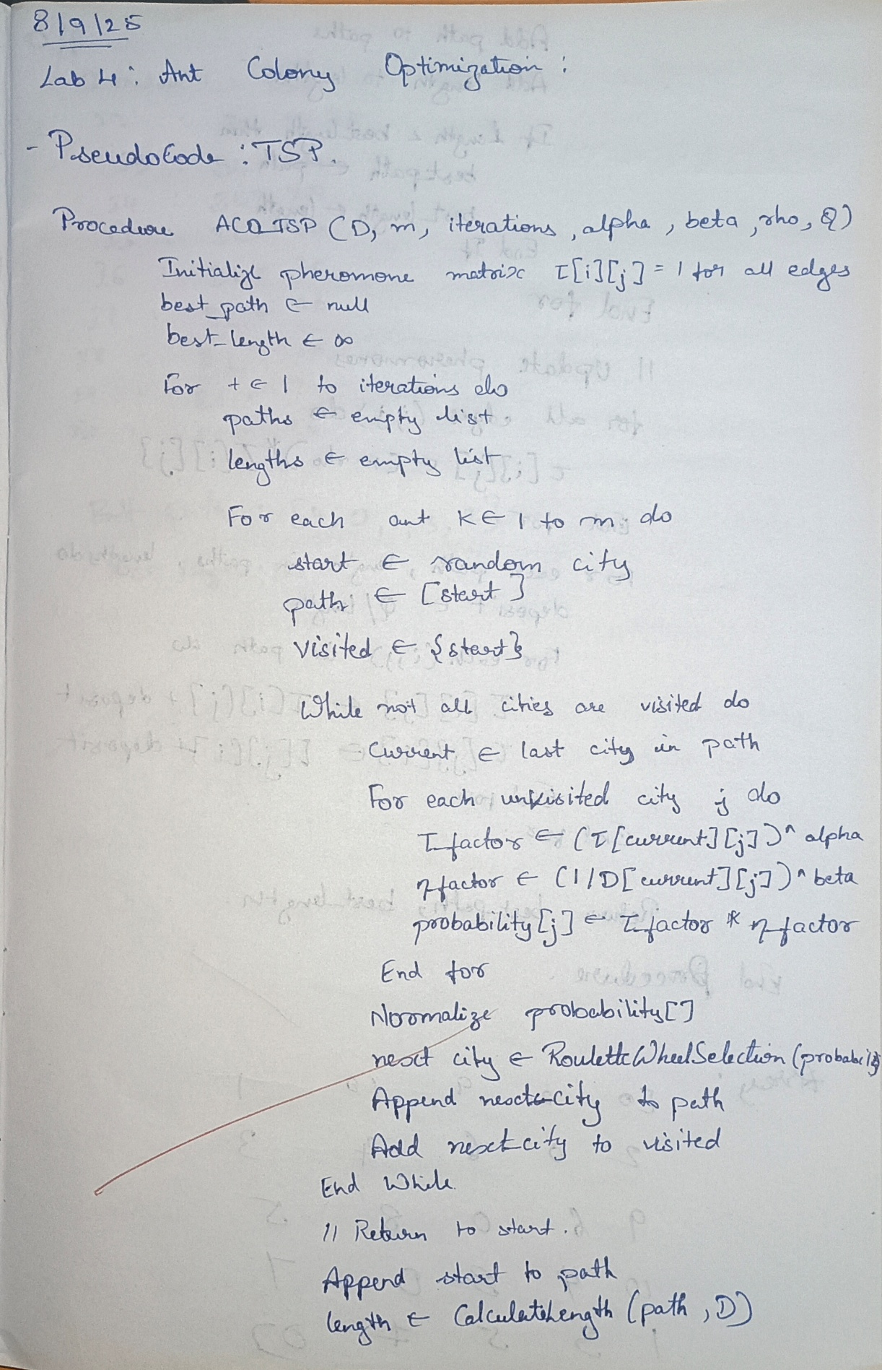

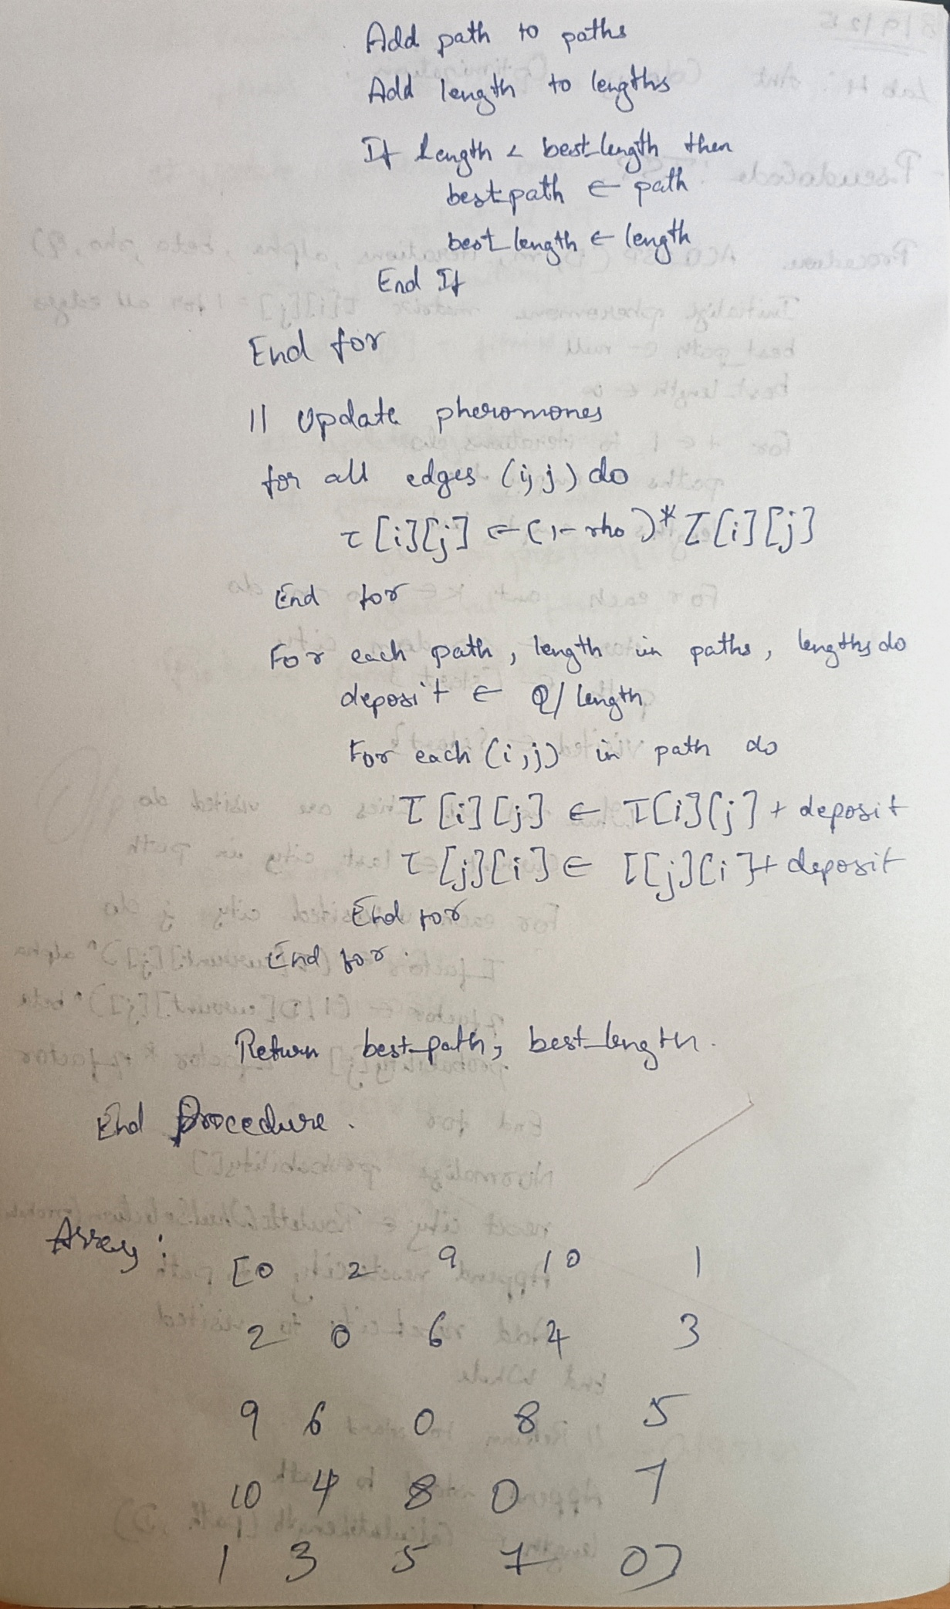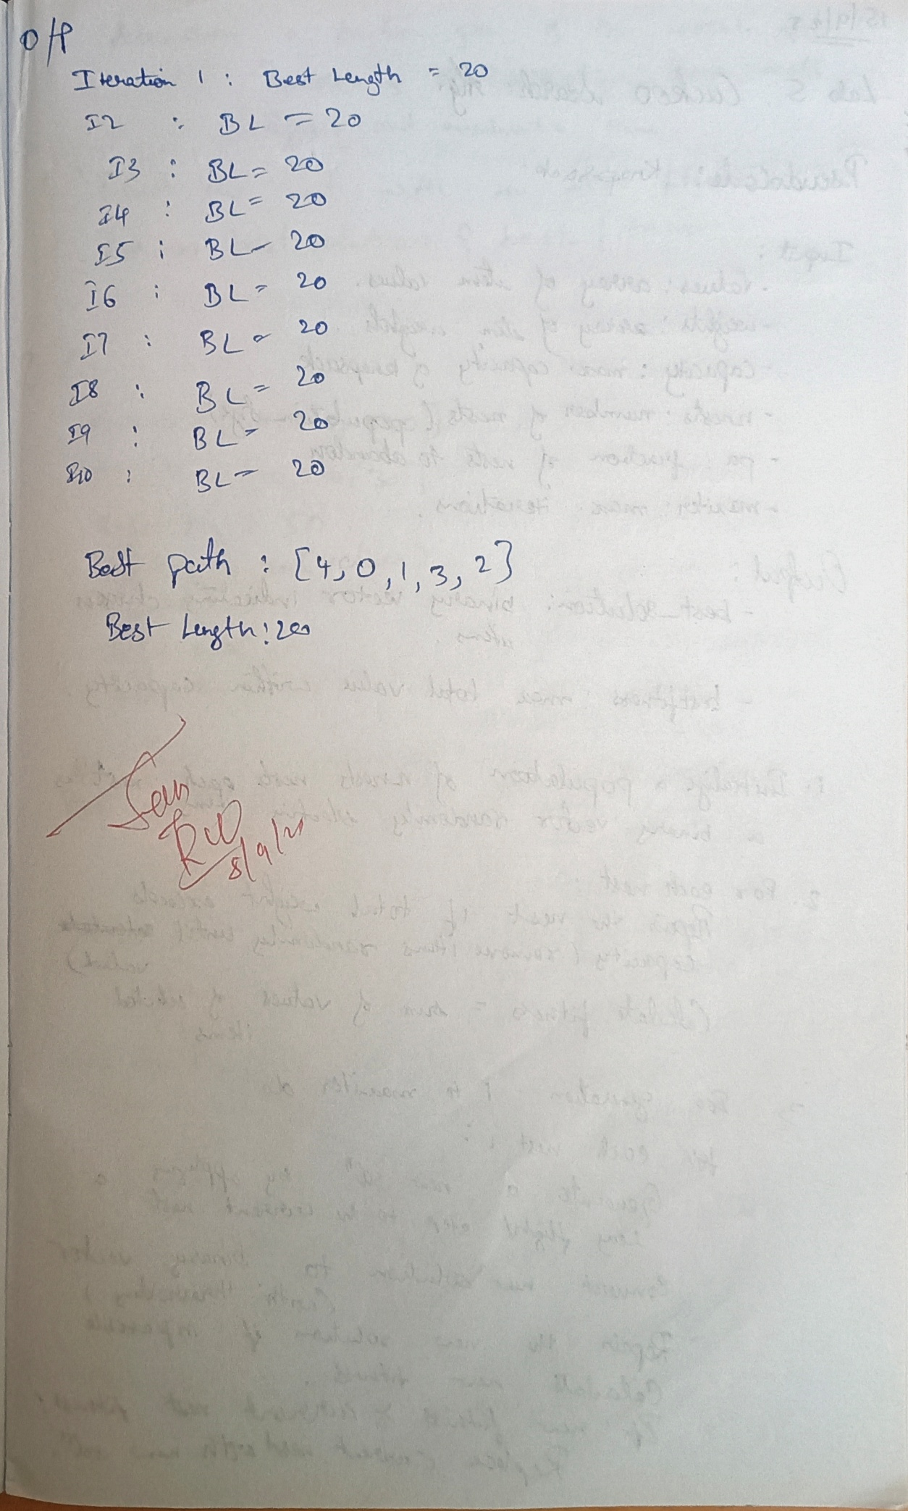

Code:

import numpy as np

import random

class ACO_TSP:

def __init__(self, distances, n_ants=10, n_iterations=100, alpha=1, beta=5, rho=0.5, Q=100):

self.distances = distances

self.n_cities = distances.shape[0]

self.n_ants = n_ants

self.n_iterations = n_iterations

self.alpha = alpha

self.beta = beta

self.rho = rho

self.Q = Q

self.pheromone = np.ones((self.n_cities, self.n_cities))

def run(self):

best_length = float("inf")

best_path = None

for iteration in range(self.n_iterations):

paths = []

lengths = []

for ant in range(self.n_ants):

path = self.construct_solution()

length = self.calculate_length(path)

paths.append(path)

lengths.append(length)

if length < best_length:

best_length = length

best_path = path

self.update_pheromones(paths, lengths)

print(f"Iteration {iteration+1}: Best Length = {best_length}")

return best_path, best_length

def construct_solution(self):

start = random.randint(0, self.n_cities - 1)

path = [start]

visited = {start}

for _ in range(self.n_cities - 1):

current = path[-1]

next_city = self.choose_next_city(current, visited)

path.append(next_city)

visited.add(next_city)

return path

def choose_next_city(self, current, visited):

probabilities = []

for city in range(self.n_cities):

if city not in visited:

tau = self.pheromone[current][city] ** self.alpha

eta = (1 / self.distances[current][city]) ** self.beta

probabilities.append((city, tau * eta))

else:

probabilities.append((city, 0))

total = sum(prob for _, prob in probabilities)

r = random.random() * total

cumulative = 0

for city, prob in probabilities:

cumulative += prob

if cumulative >= r:

return city

def calculate_length(self, path):

length = 0

for i in range(len(path) - 1):

length += self.distances[path[i]][path[i+1]]

length += self.distances[path[-1]][path[0]]

return length

def update_pheromones(self, paths, lengths):

self.pheromone *= (1 - self.rho) # evaporation

for path, length in zip(paths, lengths):

deposit = self.Q / length

for i in range(len(path) - 1):

self.pheromone[path[i]][path[i+1]] += deposit

self.pheromone[path[i+1]][path[i]] += deposit

if __name__ == "__main__":

distances = np.array([

[0, 2, 9, 10, 1],

[2, 0, 6, 4, 3],

[9, 6, 0, 8, 5],

[10, 4, 8, 0, 7],

[1, 3, 5, 7, 0]

])

aco = ACO_TSP(distances, n_ants=10, n_iterations=10)

best_path, best_length = aco.run()

print("\nBest Path:", best_path)

print("Best Length:", best_length)

**Program 5**

**Cuckoo Search (CS):**

Cuckoo Search (CS) is a nature-inspired optimization algorithm based on the brood parasitism of some cuckoo species. This behavior involves laying eggs in the nests of other birds, leading to the optimization of survival strategies. CS uses Lévy flights to generate new solutions, promoting global search capabilities and avoiding local minima. The algorithm is widely used for solving continuous optimization problems and has applications in various domains, including engineering design, machine learning, and data mining. Implementation Steps:

1. Define the Problem: Create a mathematical function to optimize.

2. Initialize Parameters: Set the number of nests, the probability of discovery, and the number of iterations.

3. Initialize Population: Generate an initial population of nests with random positions.

4. Evaluate Fitness: Evaluate the fitness of each nest based on the optimization function.

5. Generate New Solutions: Create new solutions via Lévy flights.

6. Abandon Worst Nests: Abandon a fraction of the worst nests and replace them with new random positions.

7. Iterate: Repeat the evaluation, updating, and replacement process for a fixed number of iterations or until convergence criteria are met.

8. Output the Best Solution: Track and output the best solution found during the iterations.

Algorithm:

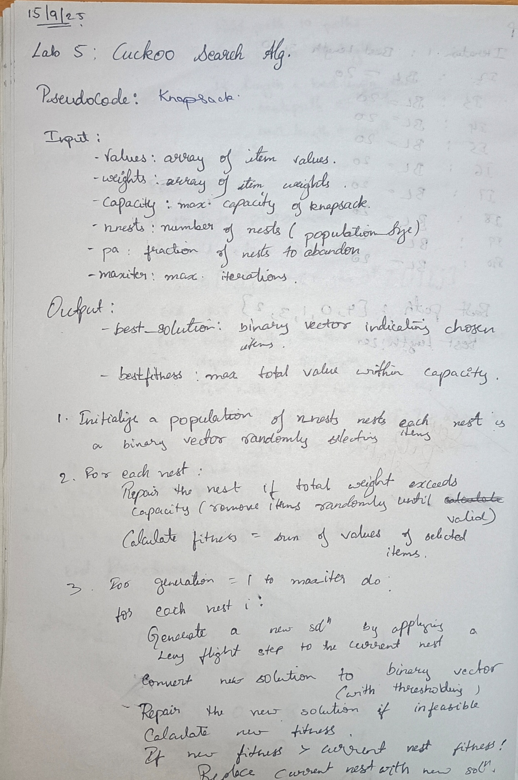

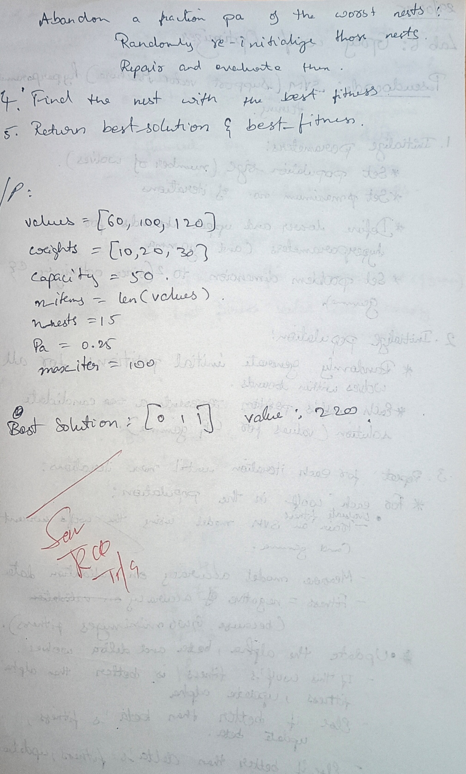

Code:

import numpy as np

import random

values = [60, 100, 120]

weights = [10, 20, 30]

capacity = 50

n_items = len(values)

n_nests = 15

Pa = 0.25

max_iter = 100

def fitness(x):

total_weight = np.dot(x, weights)

if total_weight > capacity:

return 0

return np.dot(x, values)

def repair(x):

while np.dot(x, weights) > capacity:

idx = random.choice([i for i in range(n_items) if x[i]])

x[idx] = 0

return x

def levy_flight(Lambda=1.5):

return np.random.normal(0, Lambda, n_items)

nests = [np.random.randint(0, 2, n_items) for _ in range(n_nests)]

nest_scores = [fitness(repair(x.copy())) for x in nests]

for generation in range(max_iter):

for i in range(n_nests):

new_nest = nests[i].copy()

step = levy_flight()

new_nest = np.abs(new_nest + step) > 0.5

new_nest = new_nest.astype(int)

new_nest = repair(new_nest)

f_new = fitness(new_nest)

if f_new > nest_scores[i]:

nests[i] = new_nest

nest_scores[i] = f_new

indices = np.argsort(nest_scores)[:int(Pa * n_nests)]

for idx in indices:

nests[idx] = np.random.randint(0, 2, n_items)

nests[idx] = repair(nests[idx])

nest_scores[idx] = fitness(nests[idx])

best_idx = np.argmax(nest_scores)

print("Best solution:", nests[best_idx], "Value:", nest_scores[best_idx])

**Program 6**

**Grey Wolf Optimizer (GWO):**

The Grey Wolf Optimizer (GWO) algorithm is a swarm intelligence algorithm inspired by the social hierarchy and hunting behavior of grey wolves. It mimics the leadership structure of alpha, beta, delta, and omega wolves and their collaborative hunting strategies. The GWO algorithm uses these social hierarchies to model the optimization process, where the alpha wolves guide the search process while beta and delta wolves assist in refining the search direction. This algorithm is effective for continuous optimization problems and has applications in engineering, data analysis, and machine learning. Implementation Steps:

1. Define the Problem: Create a mathematical function to optimize.

2. Initialize Parameters: Set the number of wolves and the number of iterations.

3. Initialize Population: Generate an initial population of wolves with random positions.

4. Evaluate Fitness: Evaluate the fitness of each wolf based on the optimization function.

5. Update Positions: Update the positions of the wolves based on the positions of alpha, beta, and delta wolves.

6. Iterate: Repeat the evaluation and position updating process for a fixed number of iterations or until convergence criteria are met.

7. Output the Best Solution: Track and output the best solution found during the iterations.

Algorithm:

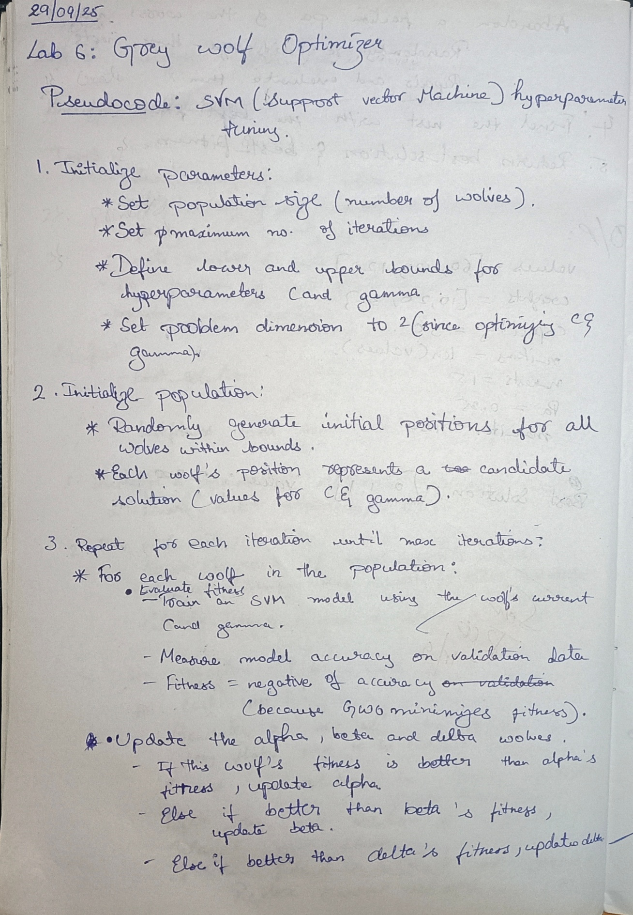

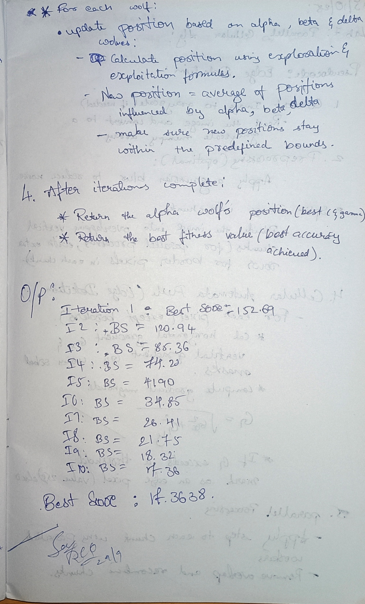

Code:

import numpy as np

class GreyWolfOptimizer:

def __init__(self, func, lb, ub, dim, pop_size=30, max_iter=100):

"""

:param func: Objective function to optimize

:param lb: Lower bounds of the search space

:param ub: Upper bounds of the search space

:param dim: Number of dimensions (variables) in the search space

:param pop_size: Number of wolves (population size)

:param max_iter: Maximum number of iterations

"""

self.func = func

self.lb = lb

self.ub = ub

self.dim = dim

self.pop_size = pop_size

self.max_iter = max_iter

self.position = np.random.uniform(low=self.lb, high=self.ub, size=(self.pop_size, self.dim))

self.fitness = np.apply_along_axis(self.func, 1, self.position)

self.alpha_pos = np.zeros(self.dim)

self.alpha_score = float("inf")

self.beta_pos = np.zeros(self.dim)

self.beta_score = float("inf")

self.delta_pos = np.zeros(self.dim)

self.delta_score = float("inf")

def optimize(self):

for t in range(self.max_iter):

for i in range(self.pop_size):

fitness_val = self.func(self.position[i])

if fitness_val < self.alpha_score:

self.alpha_score = fitness_val

self.alpha_pos = self.position[i]

elif fitness_val < self.beta_score:

self.beta_score = fitness_val

self.beta_pos = self.position[i]

elif fitness_val < self.delta_score:

self.delta_score = fitness_val

self.delta_pos = self.position[i]

a = 2 - t * (2 / self.max_iter)

for i in range(self.pop_size):

A1 = 2 * a * np.random.random(self.dim) - a

C1 = 2 * np.random.random(self.dim)

D_alpha = np.abs(C1 * self.alpha_pos - self.position[i])

X1 = self.alpha_pos - A1 * D_alpha

A2 = 2 * a * np.random.random(self.dim) - a

C2 = 2 * np.random.random(self.dim)

D_beta = np.abs(C2 * self.beta_pos - self.position[i])

X2 = self.beta_pos - A2 * D_beta

A3 = 2 * a * np.random.random(self.dim) - a

C3 = 2 * np.random.random(self.dim)

D_delta = np.abs(C3 * self.delta_pos - self.position[i])

X3 = self.delta_pos - A3 * D_delta

self.position[i] = (X1 + X2 + X3) / 3

self.position[i] = np.clip(self.position[i], self.lb, self.ub)

print(f"Iteration {t + 1}/{self.max_iter}, Best Score: {self.alpha_score}")

return self.alpha_pos, self.alpha_score

def sphere_function(x):

return np.sum(x**2)

lower_bound = -5.0

upper_bound = 5.0

dim = 30

pop_size = 50

max_iter = 10

gwo = GreyWolfOptimizer(func=sphere_function, lb=lower_bound, ub=upper_bound, dim=dim, pop_size=pop_size, max_iter=max_iter)

best_position, best_score = gwo.optimize()

print(f"Best Position: {best_position}")

print(f"Best Score: {best_score}")

**Program 7**

**Parallel Cellular Algorithms and Programs:**

Parallel Cellular Algorithms are inspired by the functioning of biological cells that operate in a highly parallel and distributed manner. These algorithms leverage the principles of cellular automata and parallel computing to solve complex optimization problems efficiently. Each cell represents a potential solution and interacts with its neighbors to update its state based on predefined rules. This interaction models the diffusion of information across the cellular grid, enabling the algorithm to explore the search space effectively. Parallel Cellular Algorithms are particularly suitable for large-scale optimization problems and can be implemented on parallel computing architectures for enhanced performance. Implementation Steps:

1. Define the Problem: Create a mathematical function to optimize.

2. Initialize Parameters: Set the number of cells, grid size, neighborhood structure, and number of iterations.

3. Initialize Population: Generate an initial population of cells with random positions in the solution space.

4. Evaluate Fitness: Evaluate the fitness of each cell based on the optimization function.

5. Update States: Update the state of each cell based on the states of its neighboring cells and predefined update rules.

6. Iterate: Repeat the evaluation and state updating process for a fixed number of iterations or until convergence criteria are met.

7. Output the Best Solution: Track and output the best solution found during the iterations.

Algorithm:

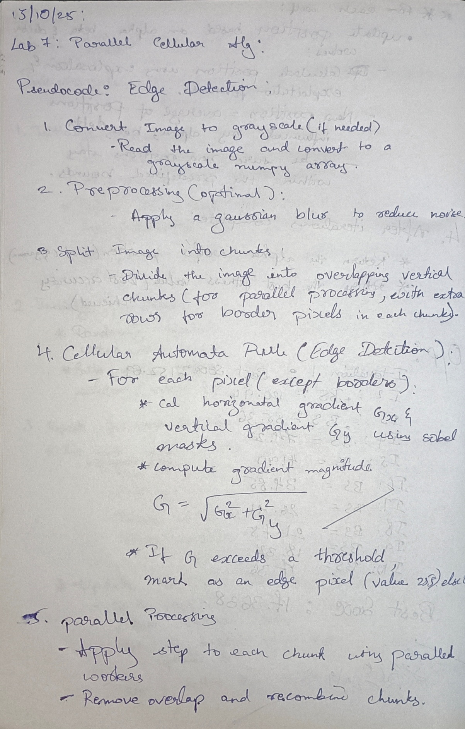

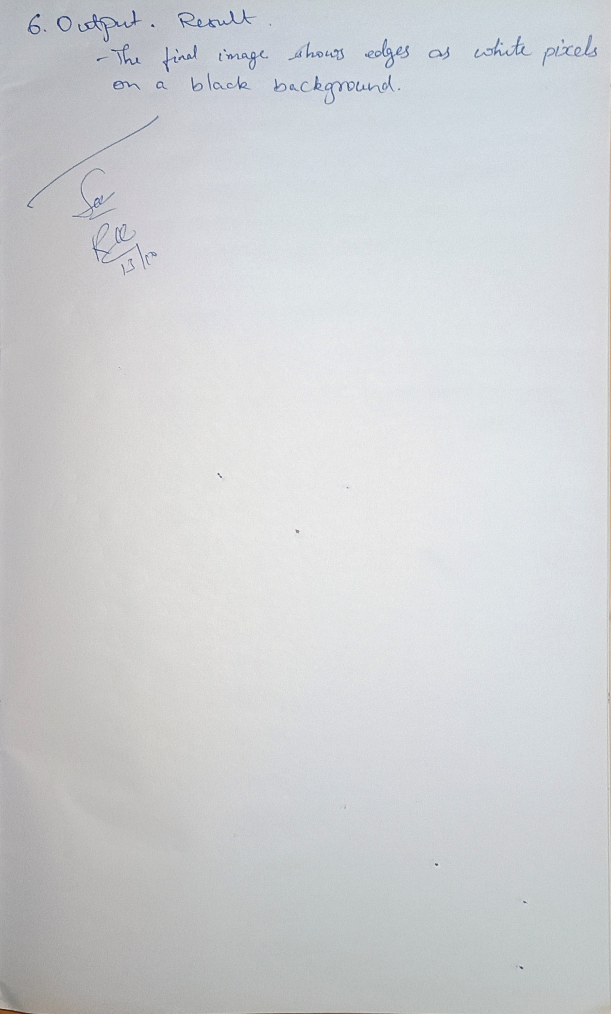

Code:

import numpy as np

from multiprocessing import Pool

def edge_rule(subgrid):

out = np.zeros_like(subgrid)

rows, cols = subgrid.shape

for i in range(1, rows-1):

for j in range(1, cols-1):

gx = (

subgrid[i-1, j+1] + 2*subgrid[i, j+1] + subgrid[i+1, j+1] -

subgrid[i-1, j-1] - 2*subgrid[i, j-1] - subgrid[i+1, j-1]

)

gy = (

subgrid[i-1, j-1] + 2*subgrid[i-1, j] + subgrid[i-1, j+1] -

subgrid[i+1, j-1] - 2*subgrid[i+1, j] - subgrid[i+1, j+1]

)

grad = np.sqrt(gx**2 + gy**2)

out[i, j] = 255 if grad > 13 else 0

return out

def get_chunks_with_overlap(img, num_workers):

height = img.shape[0]

chunk_size = height // num_workers

chunks = []

for i in range(num_workers):

start = i * chunk_size

end = (i + 1) * chunk_size if i < num_workers - 1 else height

if i > 0:

start -= 1

if i < num_workers - 1:

end += 1

chunks.append(img[start:end, :])

return chunks

def parallel_edge_detection(img, num_workers=4):

chunks = get_chunks_with_overlap(img, num_workers)

with Pool(num_workers) as p:

processed_chunks = p.map(edge_rule, chunks)

results = []

for i, chunk in enumerate(processed_chunks):

if i > 0:

chunk = chunk[1:]

if i < num_workers - 1:

chunk = chunk[:-1]

results.append(chunk)

return np.vstack(results)

if __name__ == "__main__":

import imageio

import matplotlib.pyplot as plt

img = imageio.imread('path_to_image.jpg', mode='L')

edges = parallel_edge_detection(img)

plt.imshow(edges, cmap='gray')

plt.show()

Output:

